GUIDE FOR PLANNING YOUR DL PROJECT

1. Planning, the missing step in ADDIE. DL is instruction presented with a variety of tools and techniques to engage and motivate the learner. Very often the missing step for many designers is planning. Effective DL instruction requires careful planning to ensure the most efficient use of time and resources. Effective and efficient DL design considers learning preferences, provides for immediate (or delayed) access to an instructor/facilitator, and offers diagnostic assessments that adapt the instruction to the student. These require careful analysis and planning for instructional content, tools, and techniques of delivery. To assist in the development and support of effective DL products, this guide provides detailed procedures, examples, samples, checklists, and other useful links for this important step.

a. Planning for DL begins with careful consideration of all the steps in the design and development process for both in-house and contracted work. By preparing a list of each of these steps in each phase, a fateful misstep may be prevented.

b. The steps are found in the template located at https://tadlp.tradoc.army.mil can help you to outline the steps you need for in-house work or to track the steps of your contractor.

2. Planning for IMI. Design for effective IMI provides opportunities for student interaction which engages the learner, enhances information, retention, and clarifies complex information by implementing feedback and remediation (see appendix F, Multimedia Elements Guidelines).

a. Planning the user experience:

Design the user experience with constant placement and functionality of buttons. This will keep concentration on the learning material, otherwise, students are more concerned with where things are and may miss the value of the instruction.

Similar behaviors should have similar appearance. Students should not have to guess at the functionality of these items, such as hide and show functionality. Components that have a different behavior, such as tabs, drawers, arrows, and zoom, should have a different appearance.

Visual cues, such as buttons, arrows, picture icons, textures (sliders, toggle), text style, and color should hint at functionality.

b. Maintain consistency in appearance and behavior with the following:
- Color, pattern, and texture
- Size, proportion, and rotation
- Shape
- Alignment (use grids and guides)
- Typography
- Visibility
- Transitions and motion graphics
- Rollovers/mouse-overs
- Tooltips
- Layers and pop-ups

c. Ensure visibility, discoverability, and predictability.

Interaction must be visible in order to invite and engage the student.

Hidden interactions (such as rollovers) decrease usability and efficiency. Discoverability involving luck or chance may lead to learner frustration or failure.

Set expectations about what will happen during and after an interaction to minimize confusion and dissatisfaction.

d. Reduce the learning curve.

Use meaningful and unambiguous labels, content, and interactions to make it possible to quickly understand and repeat an experience.

Learners should not have to learn a new screen dynamic with every course.

e. Acknowledge interactions.

Use clicks, fades, sound, etc. and provide information about learner status, location, progress, and completion.

Provide feedback in the context of the learned material immediately upon selection of an answer, or it may be delayed feedback after all answers are submitted.

g. Incorporate collaborative learning opportunities and mentoring with an instructor/facilitator, when possible.

d. Plan content sequence.

Present information in sequential steps. If there is no required sequence, order the steps from simple to complex.

Present prerequisite skills and knowledge necessary for student success.

Sequence content based on the instructional goal. For example, you cannot learn algebra until you learn basic math. Therefore, there is an instructional need to sequence students first through basic math.

e. Do not force sequence unless there is an instructional requirement. There is an assumption with DL that students are self-directed and self-motivated and are comfortable with learning without an instructor/facilitator or other students.
- Do not force students to listen to all the audio or watch all the video before advancing.
- Do not require all the links to be clicked or all the rollover text to be revealed before allowing students to advance.
- This means all important text is visible and does not require the adult learner to “click” for it.

f. Allow learners to control the pace. Permit learners to proceed (learn) at their own pace within certain limits (time allowed, mandatory completion date, retries permitted).

Schedule follow-on instruction at a precise date and location for learners to meet Army-directed training/education requirements.

Base management controls on the time it takes to complete the instruction and the number of times learners are permitted to retake a lesson or assessment to prove mastery of the learning objective.

Take advantage of media and present the instructional material to benefit learners. Just remember not to overdo media usage. There should be an instructional purpose for each media element.

Allow repeating of exercises/simulations many times, using and developing different solutions to problems; such as "what if" drills with time limitations.

Expose learners to unpredictable, novel situations (complexity, frequency, and timing), to maximize learning and improve job performance (enhance transfer and improve ability to solve problems).

3. Planning multimedia elements. Develop a list of the multimedia elements that will be incorporated into the courseware.

a. Multimedia elements such as graphics, video, audio, animations, and photos are developed upon the completion of the storyboards and approval of the elements. For contract-based development, these may be furnished to the contractor as part of the GFI.

b. The following are visual guidelines or recommendations for content layout, appearance, text development, and storyboards.

When developing the content layout, ensure that it is visually pleasing and provides for smooth flow from screen to screen. Place key information in prominent areas (for example, away from the border) and present recurring information (for example, titles) in constant locations.

Content layout should be clear and have continuity. This means it should be consistent regarding standardization of controls, screen placement, writing techniques (style, titles, text fonts, etc.), audio, special effects, color, and cues.

Provide consistent layout for the same types of screens (for example, checks-on-learning) within a given course. Develop and use content layout templates when possible to maintain consistency and to speed the development process.

c. The following are guidelines for content appearance.

Present information in a top-down, left-to-right format.

Ensure that key details are easily identified.

Standardize locations on the screen to display specific instructions/prompts for students.

Incorporate text that describes or labels visual elements within the graphic itself whenever possible.

Integrate diversity (gender, ethnic groups, etc.) appropriate to the target audience when developing content including graphics, animations, and text.

Use color consistently. Each color should have a clear and consistent meaning.

Ensure adequate contrast between text and background colors.

Avoid hues of colors that bleed into the background.

508 Tip

Use underlines or an image to indicate links. Color alone may not be seen by students who have difficulty perceiving color.

508 Tip

Design rollovers with a change in image or text. Changes in color alone may not be seen by students who have difficulty perceiving color.

508 Tip

Use bright colors. Some students can see all colors but have a difficult time distinguishing them if they suffer from color weakness.

Well-structured text enhances readability, increases understanding, and aids recall of information. The following are guidelines for text development.

Include a visual element (such as a graphic, animation, or video) that directly relates to the text whenever possible.

Incorporate any needed on-screen text within the visual element rather than use captions, whenever possible.

Limit the amount of text on the screen.

Put cautions, warnings, environmental protection factors, or exceptions to some prescribed action before the instructions.

Organize text into small but logical chunks of relevant information.

Keep text simple and direct.

Use a conversational and personalized style rather than a formal style.

Use short sentences and paragraphs. Break up lengthy sentences using bullets, numbered lists, tables, and/or charts.

Provide generous white space to separate blocks of text.

Start paragraphs with the main idea, followed by topically related subordinate text.

Provide the necessary information in the fewest possible steps in the shortest time possible.

Address only one concept, procedure, or item of instruction on a screen, unless it is instructionally necessary or common sense to do otherwise (for example, to compare and contrast, or to present a short series of familiar steps).

Make clear the transition from one concept to another.

Maintain parallel construction, noun-pronoun, and noun-verb agreement.

Use active voice whenever possible.

Use bold for emphasis. Avoid underlining except for hyperlinks.

Align text flush left, ragged right. Avoid indenting paragraphs.

Use uppercase words sparingly (for example, titles); avoid using words in all uppercase.

Hyperlink glossary words, when appropriate.

Avoid scrolling by using more pages when presenting large amounts of text.

Avoid using paragraphs of on-screen text, narration, and visual elements (such as graphic, animation, or video) simultaneously.

4. Planning visual elements. Audio and visuals should only be used when they will help to enrich the learning experience.

a. Visuals present information with some type of graphic. Only use visuals that relate directly to achieving the learning objective and content.

b. The following are guidelines for visual elements:

Balance selection of graphics with the bandwidth required and the characteristics necessary to support the learning objective (for example, still picture, animation, or narration).

Ensure graphics, photographs, and animations have a consistent appearance by establishing standards (for backgrounds, size, color, borders, etc.).

Incorporate any needed on-screen text within the visual element rather than using captions, when possible.

Use visual representations of text (such as graphic organizers, concept maps, hierarchies, matrices, flowcharts), whenever possible.

Reuse graphics to reinforce basic concepts.

Provide recurring information in consistent locations (such as buttons or navigations).

Maintain a constant perspective in a series of visuals. Cue learners if a change of perspective is necessary.

Title charts clearly with appropriately sized fonts.

Avoid overloading charts with small symbols or graphics.

Avoid cluttering the screen with too many visual elements.

Do not include brand name, contractor, or other corporate logos.

c. Graphics include clip art, drawings, charts, animations and tables.

The following are guidelines for static graphics/photographs:

508 Tip

Ensure adequate contrast between subject and background colors.

Ensure that key details are easily identifiable. Avoid using too many visual cues or too many colors at once.

The following are guidelines for animation:

Combine animation with narration rather than with chunks of on-screen text, where possible.

Incorporate student interaction into animations, where instructionally sound.

Allow students to play, pause, and repeat animation.

Use animation to show key concepts that are difficult, impossible, or cost-prohibitive to describe otherwise, especially when the animation (or parts of it) can be reused elsewhere in the course or on a splash screen.

Match the duration of animation with narration to avoid long pauses.

508 Tip

Use color to alert the learner to critical situations requiring immediate attention or action. No blinking text or banners.

Avoid animation that wanders across the screen or otherwise distracts from the content.

d. Video should only be used when it is essential to teach a specific learning objective, because video consumes memory and bandwidth. The following are guidelines for video:

Use video to reinforce, clarify, or emphasize a specific learning objective that cannot be taught effectively using graphics, stills, photographs, or animations.

Use the appropriate method of instruction (such as demonstration, panel discussion, or guest speaker) for the content presented.

Light the main subject well and eliminate background distractions.

Use video or graphic window overlays to show extreme close-ups of small objects, such as wide-angle views for knobs and switches.

Provide media controls to play, pause, and repeat video.

Play video automatically as soon as the page is loaded unless there is an instructional need for learners to initiate it (then, provide a "play" button).

Allow learners to proceed without viewing the video.

Use a separate page for video scripts and reference the corresponding screen number. Use a two-column format. In the left column, describe the scene to be developed. In the right column, state the actual words to record.

Plan video segments in advance of the editing process to avoid excessive costs.

Film several takes of the same scene or subject with adequate footage before and after to facilitate editing.

For Web-based delivery, avoid traditional techniques (such as zooming, panning, transitional wipes and dissolves, or fast motion subjects) that increase the duration and file size unless they are instructionally necessary.
Note: Audio with a photograph is often just as effective as a video of a talking head. Use the talking head format only when an expert is used to motivate students.

e. Interactive graphics are used to provide an application or hands on practice to the instruction. The following are guidelines for interactive graphics:

Allow students two opportunities to complete the interactivity whenever possible.

Provide descriptive feedback on the same screen, if applicable.

f. The following are guidelines for three-dimensional graphics:

Use to show key concepts that are difficult to describe, or are impossible or cost-prohibitive to photograph or film.

Consider using when the graphic or parts of the graphic can be reused elsewhere in the course to save on overall development time.

Consider "hybrid" animations that use three-dimensional imagery and two-dimensional animations to reduce file size.

g. The following are guidelines for three-dimensional visualizations:

Ensure equipment parts are recognizable.

Allow students to drill down to greater detail.

Limit the number of individual parts, preferably less than 50.

Consider using colors instead of textures on some, or even all, parts unless instructionally necessary.

Reduce or eliminate backgrounds unless there is an instructional need to display them.

h. The following are guidelines for real-time simulations:

Use when students must act on realistic scenarios without attendant dangers and inefficiency (time and money).

Use for exploration and reflection.

Incorporate demonstrations, coaching, and explanations whenever possible.

Consider making levels of increased difficulty, such as beginner and advanced levels.

5. Planning audio elements. The following are guidelines for planning audio elements:

State in the storyboard the actual words or sounds to record. If additional space is necessary, add a page.

Provide complete closed captioning.

508 Tip

Spell out all numbers for the script/narration.
Note: This is not meant for on-screen text.

508 Tip

Do not have the narrator read on-screen text word for word. Provide complete closed captioning

Indicate how to pronounce acronyms and unfamiliar words for the script/narration (for example, A-T-S-C).
Note: This not meant for on-screen text.

Use a conversational style rather than a formal style.

Use short sentences and define acronyms, if used.

Provide students with the necessary information in the fewest possible steps, in the shortest time possible.

Make clear the transition from one concept to another; use transitional words such as "first," "second," "next," or "as a result."

Use active voice whenever possible.

Allow students to play, pause, and repeat audio.

Allow students to proceed without playing audio.

Write narration and dialogue to include a preview summary that outlines the main steps.

Organize narration and dialogue into short, logical chunks that are simple and direct.

Set narration to play automatically (as soon as the page is loaded) for individual page narration.

Write narration that supports on-screen text and graphics, rather than competes with them.

Use combinations of narration and visual elements rather than combinations of paragraphs of on-screen text and visual elements.

Match the duration of narration with animation to avoid long pauses.

Use sound effects to add realism, when appropriate.

Avoid sound effects that indicate correct or incorrect responses, as they can quickly become irritating.

6. Planning text elements. Text is used to present information and communicate ideas, procedures, and concepts. Text that is cluttered and hard to read does not help to accomplish any of these goals. The following are guidelines for planning text elements.

Place text as it will be read (left to right and top to bottom).

Minimize text on a single screen.

Be concise.

Do not scroll the text, if information is critical.

Select text size and font that are easy to see and read.

508 Tip

Use fonts that are sans serif (without flourish) for on-screen and Web-based viewing. Use of text types or fonts with a flourish (serif) can result in poor readability.

Determine text size based on the students' ability to easily see and read the information. Size is determined by font selection. General guidelines are headings (48 points), titles (36 points), and body (24 points), but these may change based on font selection.

Remain consistent in font size and type throughout the material.

508 Tip

b. The following are guidelines for selecting text color.

Avoid using high-chroma, brilliant, or electric colors for text fields since they make reading difficult.

Ensure text and graphic colors contrast with background color.

Use color text combinations that aid reading or viewing.

Use white or light yellow text for dark backgrounds.

Use blue, black, or dark text for light backgrounds, such as beige.

Use color background combinations to identify the type of screen (such as procedure, checks-on-learning, caution, warning, or menu).

Specify color combinations in the IMI design strategy conventions.

There are many ways to enter text into IMI. The entry method depends on authoring tools used in the design. The following are guidelines for entering text.

Typing with a keyboard directly into an authoring tool is the normal method. This must be done keeping students in mind. View the text in the same manner the students will see it to ensure the text is of appropriate size, color, and contrast.

Scanning or importing text as a graphic image. While this method is possible, caution must be exercised. A scanned image may lose resolution when stretched to fit a design.

Using a graphic representation of text can result in poor, unreadable text. Use caution with this technique.

7. Planning for development time. In planning IMI, it is useful to consider the amount of time required to develop the project. This provides a basis for evaluating a cost-to-benefit decision.

a. Estimate development hours. Certain factors and variables can affect the development time required to develop one hour of completed IMI. The following list of factors defines a best-case situation:

The developer is familiar with the subject matter and has access to in-house subject matter experts (SMEs).

The subject matter is not highly complex.

The instructional content is stable. In other words, the system for which the IMI is being developed exists and is not emerging, and the tasks selected for IMI DL do not continually change.

The instructional content is well documented. A needs analysis and task analysis are complete, giving the developer a good idea of the performance expected and tasks to teach. The technical materials supporting the IMI development are accurate and available.

The developer is familiar with the selected IMI authoring software.

The developer is familiar with the target audience.

The development team consists of individuals experienced with IMI management, design, and development.

The selected IMI authoring system is mature and stable. No beta versions are used.

A lesson format, to include the design strategy, is agreed upon in advance and management has approved the strategy, prototype lesson, and lesson specifications.

The development process is standardized.

An instructional strategy is approved and a wireframe is tested.

The Contracting Officer Representative (COR) and SME work closely with the development team on a regular basis. The COR uses objective acceptance criteria and does not continually change the individual responsible for reviewing and approving the lessons.

Best commercial practices are accepted for software development and video production. There is no requirement to document to an Army standard.

All required resources are in place.

b. Determine development time. This following paragraphs provide a baseline estimate to begin the process of determining the total number of hours required to design, develop, and evaluate one hour of IMI. Table 1 lists estimated hours of development for one hour of IMI. Centers and schools may use these optional time values (for planning purposes only) to help plan, or contract for, IMI development. Do not use the estimated times for staffing purposes. For a full discussion of levels of interactivity, see appendix D, Student Control, Navigation, and Interaction.

Table 1
Estimated hours to develop one hour of IMI
Level of interactivity | Estimated time
0. Passive | 50-150
1. Simple | 150-200
2. Complex | 200-500
3. Real-time | 500-1000
4. Immersive environment | 1000-2000

c. Identify factors affecting development. Many factors might affect the IMI development effort with some that might impact the cost and timeliness of the product. See table 2 for factors affecting development.

Table 2
Factors affecting development
Factors | Increase number of hours by: | Risk scale  (none = 1, high = 5)
1. No "in-house" SMEs; must rely solely on use of proponent SMEs. | 25 | 2
2. Subject matter is highly complex. | 100 | 4
3. Instructional content is unstable. System for which IMI is being developed is emerging. Tasks for IMI constantly changing. | 100 | 5
4. Inadequate documentation. No needs assessment performed. No task analysis or learning analysis data. Technical manuals nonexistent or not helpful. | 20 | 4
5. Total IMI course length less than 100 hours (less potential for use of templates, shell, etc.). | 20 | 1
6. Developer not familiar with IMI software package/authoring tool. | 15 | 2
7. Developer not familiar with target audience. | 10 | 2
8. Best commercial practices not acceptable for video, graphics, and software development. Must develop to a specification and deliver large amount of documentation. | 50 | 2
9. Inexperienced development team:  - Developer inexperienced.  - Manager inexperienced.  - Programmer inexperienced. | - 80  - 100  - 60 | 3-4
10. Using a beta version of the authoring tool. | 80 | 4
11. Design plan is not approved. No standardized development process to follow. | 50 | 5
12. Management not using objective and consistent acceptance criteria. Management unsure of what is needed, and does not communicate with developer. | 50 | 5
13. Required resources not in place at start of project. | 20 | 1

d. Once the desired level of interactivity is determined, the developer can review the internal team and access to resources. A simple calculation helps to see the impact of such things as the skill level of the team, access to subject mater experts, and stability of the content. These all contribute to the production time for one hour of IMI (Figure 3).

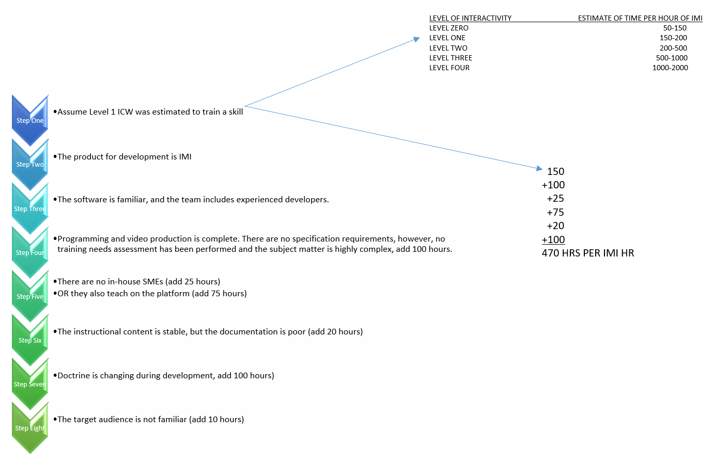
Figure 3. Factors' impact on development example

e. Estimate impact of changes. Examples of changes often encountered during IMI development are in table 3. The table shows the degree of effort commonly associated with minor, moderate, and major changes. Degrees of effort are used to help the manager single instance. Multiple instances of the same occurrence will impact the degree of effort involved.

Table 3
Degree of effort associated with changes
Type of change | Examples and associated degree of effort
 | Minor | Moderate | Major
1. Technical | Switch position is wrong. | Change functioning of an entire component due to an equipment modification. | Introduce entire set of new tasks.
2. Instructional | Allow student two tries, instead of one. | Change one multiple choice assessment to another format. | Introduce entire new strategy on how to assess.
3. Media | Change font. | Add four full-motion video shots. | Replace all graphics with video.

f. Price IMI development. After determining development time, the price for that development can be estimated using the presentation categories as defined in tables 4 and 5. The presentation categories are initially derived from the level of interactivity related to the learning objective, but this is only one element of cost. Contractors base contract pricing on the complexity of the courseware, the levels of interactivity, and the development costs associated with audio and video.

Table 4
Presentation categories
Category | Description
Category 1:  low-grade presentation | - This is the lowest (baseline) category of IMI development. It is normally a knowledge or familiarization lesson, provided in a linear format (one idea after another).  - Category 1 is used primarily for introducing an idea or concept. Students have little or no control over the sequence and timed events of the lesson material.  - Minimal interactivity is provided by selective screen icons and inserted into the lesson through typical input/output peripherals and programming protocols.  - This category may include simple developed graphics and/or clip art, customer provided video and audio clips. Instruction will be delivered by stand-alone personal computer.
Category 2:  medium-grade presentation | - This category involves the recall of more information than a category 1 presentation and allows students more control over the lesson's scenario through screen icons and other peripherals, such as light pen, touch screen, track ball, or mouse.  - Typically, category 2 is used for non-complex operations and maintenance lessons.  - Simple emulations or simulations are presented to students. For example, students are requested to rotate switches, turn dials, make adjustments, or identify and replace a faulted component as part of a procedure.  - This category also may include simple to complex developed graphics, clip art, and audio with customer-provided video clips and animation.
Category 3:  high-grade simulation presentation | - This category involves the recall of more complex information (compared to categories 1 and 2) and allows students an increased level of control over the lesson scenario through peripherals such as light pen, touch screen, track ball, or mouse.  - Video, graphics, or combinations of both are presented simulating the operation of a system, subsystem, or equipment.  - The lesson scenario instructional material typically is complex and involves more frequent use of peripherals to transfer learning.  - Operation and maintenance procedures are normally practiced with category 3 scenarios and students may be required to alternate between multiple screens to keep pace with the lesson content.  - Multiple software branches (two to three levels) and rapid response are provided to support remediation.  - Emulations and simulations are an integral part of this presentation.  - This category may also include complex developed graphics, and/or clip art, and the development of video, audio, and animation clips.
Category 4:  Real-time simulation presentation | - This IMI category involves more in-depth recall of a larger amount of information (compared to categories 1, 2, and 3) and allows students an increased level of control over the lesson.  - Every possible subtask is analyzed and presented with full, on-screen interaction, similar to the approach used in aircraft simulator technology.  - The lesson content is extremely complex and involves more frequent use of peripherals to transfer learning.  - This category normally supports certification, recertification, or qualification requirements.  - Complicated operation and maintenance procedures are normally practiced with category 4 and involves all of the elements of categories 1, 2, and 3 presentations plus the following:  - High degree of interactivity.  - Extensive branching (four or more levels).  - Levels of sophistication — short of artificial intelligence.
Category 5:  Immersive environment | - This IMI category involves recall of a large amount of information (compared to category 3) and allows students total control over the lesson.  - Every possible subtask is analyzed and presented with full, on-screen interaction. The learner is allowed to complete the lesson without any instructional guidance but is provided a detailed after action report.  - The lesson content is extremely complex and involves more frequent use of peripherals to transfer learning.  - This category normally supports certification, recertification, or qualification requirements.  - This category is presented as part of instructor led classroom training.  - Category 5 normally presents complicated operation and maintenance procedures using fully validated 3D models  - High degree of interactivity.  - Real life environment.  - Levels of sophistication — short of artificial intelligence.

Note: Typically, presentation category 1 uses level 0 interactivity, with simple visuals and basic instructional delivery mode. However, a level 1 interactivity may require complex visuals (that is, high-fidelity computer-generated graphics, space, and photography) or complex instructional delivery mode (such as a flight simulator) raising the cost of development.

g. The presentation category is selected based on the level of interactivity, the complexity of the visual requirements, and the complexity of the instructional delivery mode.

h. Once the presentation category has been determined, it can be recorded on the checklist. Next, the level of interactivity is determined based on the learning level and the type of interaction planned for students with the content. This is also recorded in the checklist (see the example in figure 3-3, below).
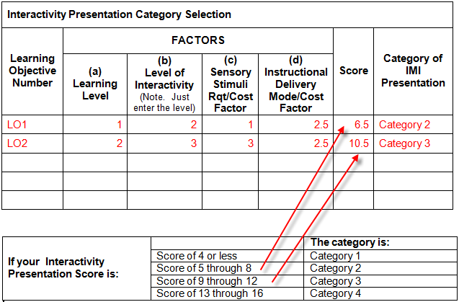
Figure 3. Presentation category selection example

i. Learning level and scores. Learning content is:
- Fact learning, rule learning, and perception (equals 1).
- Procedure learning, readiness, guided response, receiving, and responding (equals 2.5).
- Discrimination learning, problem-solving, mechanism, origination, continuous movement, adaptation, valuing, and competence (equals 4).

j. Levels of interactivity. Rate the level of interaction students will be engaged in with the levels of interactivity. Level of interactivity is:
- Passive (equals 0) when students are solely receivers of information.
- Limited interactivity (equals 1) when students make simple response to instructional cues.
- Complex participation (equals 2) when students make a variety of responses using varied techniques in answer to instructional cues.
- Real-time participation (equals 3) when students are directly involved in a life-like set of complex cues and responses.
- Immersive environment (equals 4) when students are directly immersed in a life-like without cues and or visual responses.

k. Sensory stimulus requirement/cost factor. Identify the sensory stimulus requirement necessary to support the learning objectives. Assign a cost factor (low, medium, high) to each sensory stimulus requirement. The cost factors are:
- Low (equals 1) when using commercially available or GFM (graphics, animation, audio recordings, digital video recordings, photography, etc.). Costs are limited to physical integration into courseware.
- Medium (equals 2.5) when development of original materials or adaptation of existing materials is required. Limited amount of resources are required to develop them. For example, two-dimensional graphics will probably be in the medium cost category
- High (equals 4) when development of original materials is required. More complex efforts and resources are required to develop than for medium. For example, high fidelity computer-generated graphics, complex animation, three-dimensional graphics, and complex video production

l. The presentation category is selected based on the level of interactivity, the complexity of the visual requirements, and the complexity of the instructional delivery mode.

The example in Figure 4 is a category 0 low-grade presentation because it involves passive viewing with simple graphics.
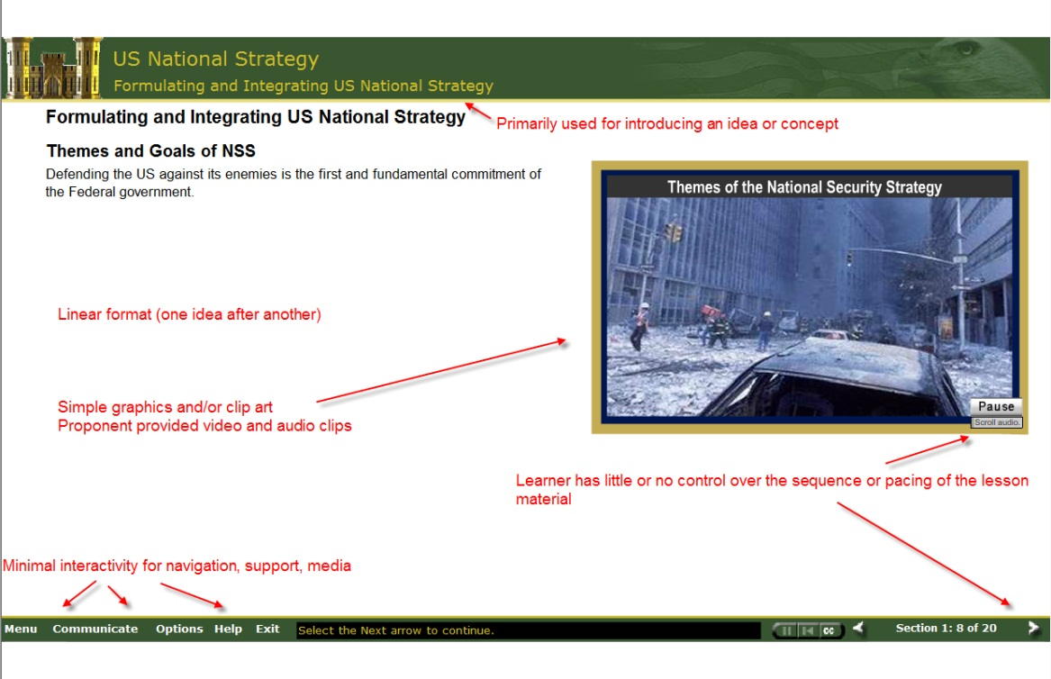
Figure 1. Category 0 low-grade presentation

The example in Figure 5 is a category 1 high-grade simulation presentation. The difference between figures 4 and 5 is in the fidelity of the graphical presentation that was developed specifically for the product.
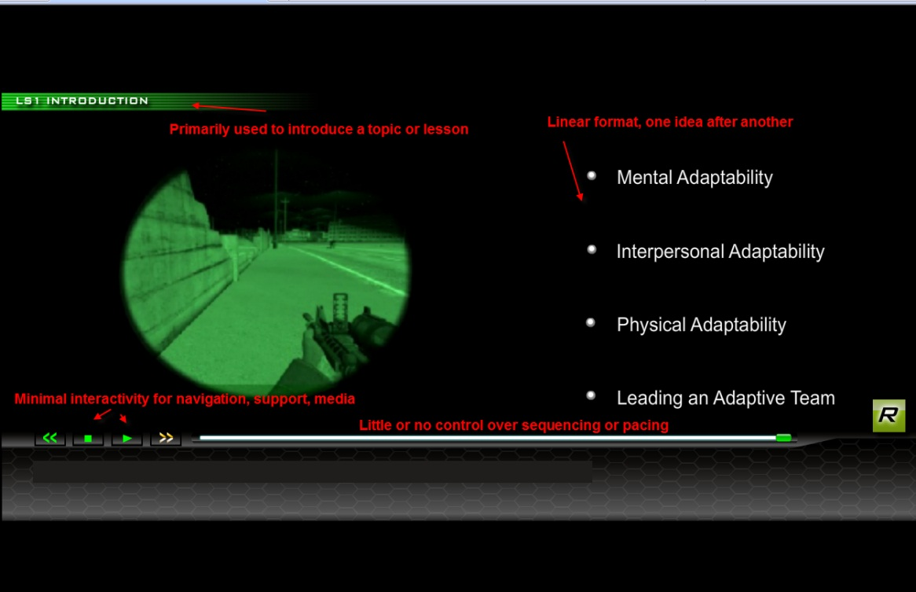
Figure 2. Category 0 high-grade simulation presentation

The example in Figure 6 is a category 2 medium-grade presentation. It has simple interaction, no instructional branching, and complex graphics.
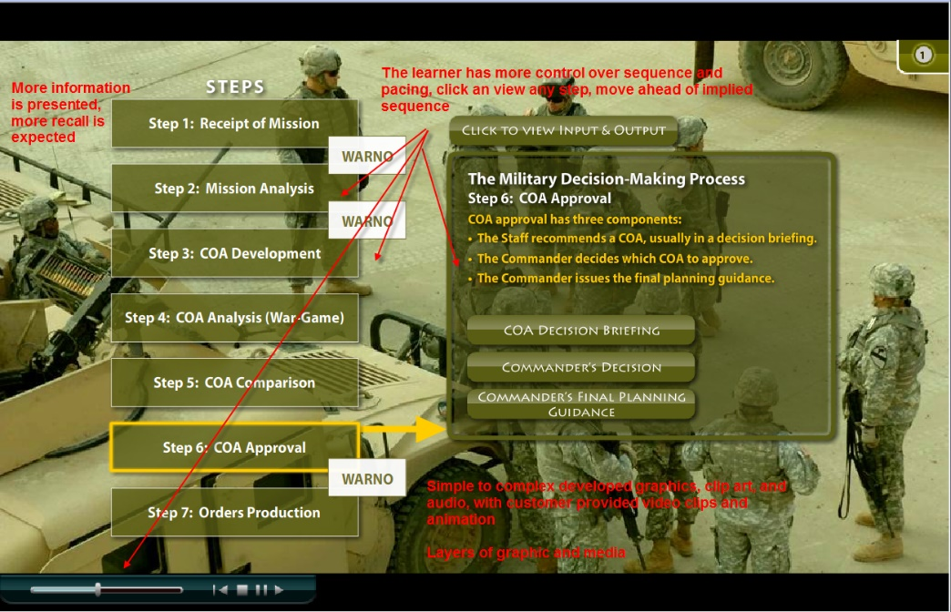
Figure 3. Category1medium-grade presentation

The example in Figure 7 is a category 2 medium-grade presentation. It has simple graphics, simulated interaction, no instructional branching, and some control.

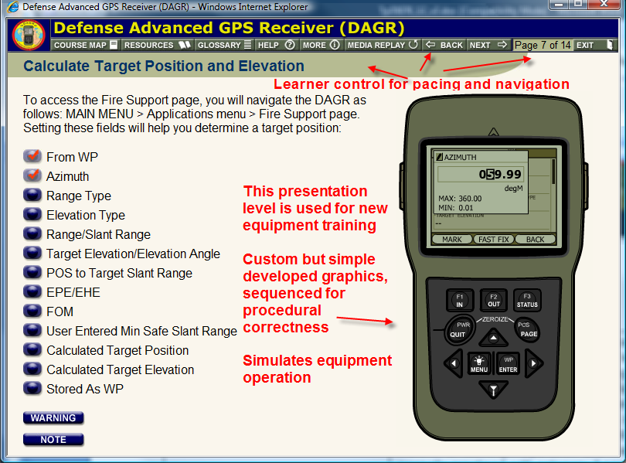
Figure 4. Category1 medium-grade presentation

The example in figure 8 is a category 3 high-grade simulation presentation. It is a simulation of a process and has complex graphics, more control, and instructional branching.
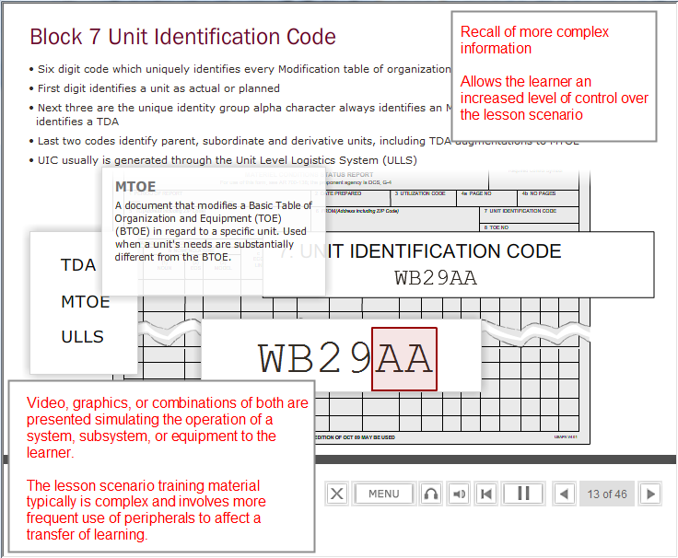
Figure 5. Category 2 high-grade simulation presentation

The example in figure 9 is a category 4 high-grade simulation presentation. It is a real-time simulation and has complex graphics, real-time control, and instructional branching.
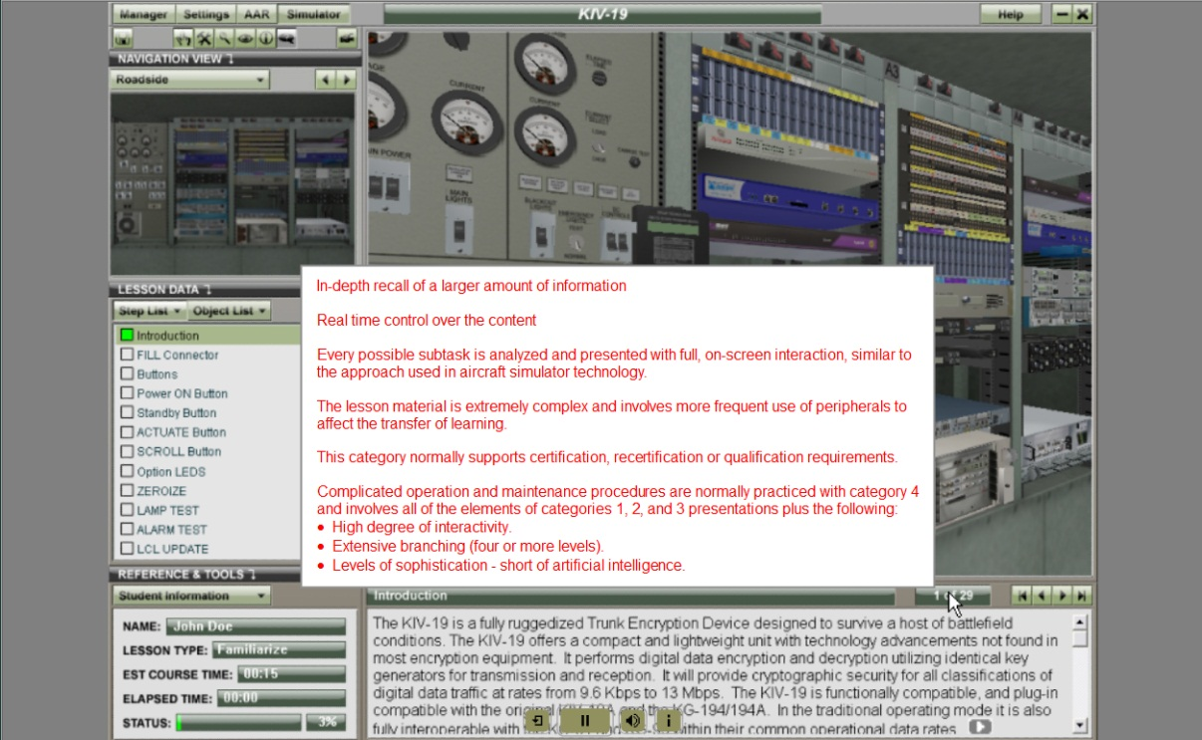
Figure 6. Category 4 high-grade simulation presentation

The example in figure 10 is a category 5 high-grade simulation presentation. It is a virtual environment and has complex 3D graphics, real-time control, and some instructional branching. This type of presentation is for hands on practice in the classroom. Content may require use of virtual reality googles.

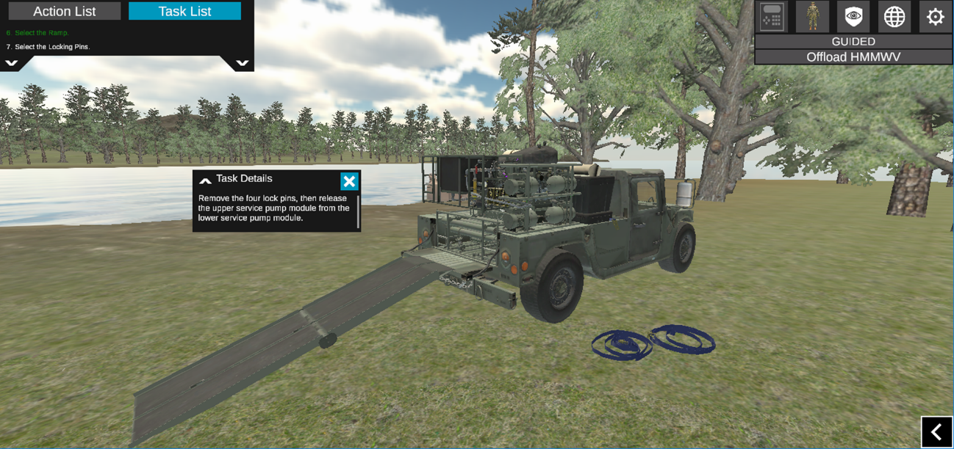
Figure 10. Category 5 high-grade virtual environment

8. Planning for Sharable Content Object Resource Model (SCORM)-conformant content.
The SCORM is a collection of standards and specifications for web-based electronic educational technology. It defines communications between client side content and a host system (called "the run-time environment"), which is commonly supported by a learning management system..

a. SCORM-conformant courseware is not substantially different from any other type of courseware. Sharable content objects need to adhere to appropriate chunking, reuse, and reach-back abilities. This cuts down on the overall size of the courseware components. Also, SCORM requires two extra steps in the planning process:

(1) Plan the course. First, SCORM requires developers to think in terms of content that can be reused or repurposed. This can mean substantial savings in time and development costs.

(a) Analyze each component of the IMI (pre-assessment, an introduction, a knowledge-based presentation, a graphical diagram, post-assessment, etc.) for reusability. It is likely that a graphical diagram or a set of procedures may be used again. This analysis helps to identify dependent and independent content.

(b)Prepare a course map. The course map assures that programmers can establish the correct instructional sequence and structure your content correctly in the LMS (Figure 9).

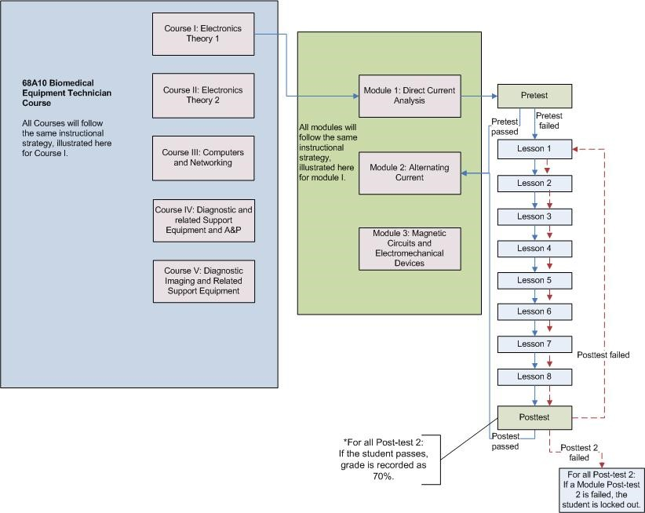
Figure-9 Sample Course Map

(c) Develop courseware logic flow diagrams. With SCORM, flow diagrams are used to check the sequencing.

(d) Establish sequencing and navigation. With SCORM, sequencing and navigation can be directed by the LMS, there is an exception. One new area of this functionality is performance-conditional branching. In this content design, a shareable content object (SCO) may contain a user interface device that allows students to trigger a navigation request. This means that developers may use a button or graphical image such as a forward arrow to direct students through course content separate from the navigation directed by the LMS. This type of strategy requires consultation with a SCORM programmer.

(e) Search for reusable content. Second, when planning the course, search content repositories such as the Central Army Registry (CAR) for course content previously developed that can be reused in new courseware.

(f) Additional considerations in the planning process are the project's technical requirements, delivery platform (Army Learning Management System (ALMS), content management system, DVD-based, etc.), technical resources, course navigation, and sequencing.
Note: SCORM is not required for all IMI. You will want to be SCORM conformant if you require tacking of learner progress and performance, use an LMS to delivery and manage learning content, or designing for reusability. SCORM is not required if your content is short lived, do not intend to use an LMS for delivery, or have simple static content as reference material.

9. Planning for mobile learning products. Planning for mobile products begins with careful consideration of all the steps in the design and development process for both in-house and contracted work. By preparing a list of each of these steps in each phase, a fateful misstep may be prevented. The steps, found in the template located at http://www.atsc.army.mil/tadlp/content/index.asp , can help you outline the steps you need for in-house work or to track the steps of your contractor. Mobile learning strategies include:

a. mLearning. Persistent link to formal and tracked learning content via a learning management system (LMS).

b. mLearning. Downloadable or preloaded content to support learning originally delivered in residence or in the unit, via distributed learning.

c. mLApps. Gaming, simulations, assessments, etc. that the learner can access via an App store. With mLApps, the learner searches and accesses content to enhance previous learning by practice or game playing or by self-knowledge checks.

d. General Considerations. The decision to include mobile delivery for all or part of your content may happen as a result of media, or it may happen as a result of policy changes from the top directing some or all of your content be delivered in this way. In both cases, the designer must remember the end state, a well trained Soldier or Civilian. To achieve the desired end state proper instructional design principles should be followed.

(1) Some examples of when mobile learning could be used include:

- To deliver content (“Just-in-time” learning, micro learning, reach-back/review )
- To deliver just-in-time performance support (Alert, reminders, procedures, job aid, forms and checklists, decision support)
- To deliver reference materials (Field guide, presentations, podcasts, updates and alerts, audio recordings, video recordings )
- To use as an e-Book (e.g., field manuals, training manuals)
- To engage students in collaborative activities (Coaching, conferencing, feedback, mentoring, social networking)
- To provide an assessment (Quiz, evaluation, test, survey or poll, reporting, certification)
- To take advantage of some unique mobile capabilities such as GPS, games and applications
- To allow for user-generated content (Note taking, transcription, translation)

10. Planning for accessibility. Section 508 of the Rehabilitation Act of 1973 requires each federal department or agency, when developing, procuring, maintaining, or using electronic and information technology (E&IT), to ensure that federal employees with disabilities to have access to, and use of, information and data that is comparable to federal employees without disabilities. In addition, members of the public with disabilities, who seek information or services from a federal department or agency, must have access to and use of information and data that is comparable to the access to and use of the information and data by members of the public without disabilities.

a. The act exempts national security systems (as defined in the National Defense Authorization Act (Clinger-Cohen Act) for fiscal year 1996, Section 5142 (40 USC 1452)) from the provisions of Section 508. The Clinger-Cohen Act defines national security systems as telecommunications and information systems that involve:

Intelligence activities.

Cryptologic activities related to national security.

Command and control of military forces.

Equipment that is an integral part of a weapon or weapons system.

A function or operation that is critical to the direct fulfillment of military or intelligence missions. This does not include a system used for routine administrative and business applications (including payroll, finance, logistics, and personnel management applications).

b. Electronic and information subsystems procured and operated under the distributed learning system must comply with Section 508. Digital Training Facilities (DTFs) incorporate assistive technology devices and equipment, as well as ergonomic workplace solutions, when and as required, to assist developmentally or physically challenged individuals to accomplish effective computer use. These systems are independently certified for Section 508 compliancy.

c. Unless an exception provided for by the Act applies, individual DL courses must comply with Section 508. Consult with DDL on the requirements of the planned course or content.

d. Courses selected for development are examined on a case-by-case basis to determine the applicability of Section 508. This examination results in one of the following outcomes:

Course content is exempt from Section 508 IAW the Clinger-Cohen Act of 1996.

Course content is provided to physically or developmentally challenged individuals through alternate means.

Course content complies with Section 508 standards.

e. The standards established to comply with Section 508 are stated in terms of technical and functional performance criteria, as opposed to technical design requirements. Performance criteria gives discretion in achieving the required end result.

f. Section 508 and the standards build as much accessibility as is reasonably possible into general products that agencies develop, procure, maintain, or use. Not every computer is equipped with a refreshable Braille display, nor will every software program have a built-in screen reader. Agencies may require such assistive technology as part of a reasonable accommodation for an employee with a disability, or to provide program accessibility.

g. The Architectural and Transportation Barriers Compliance Board (Access Board), an independent federal agency, published technical standards for E&IT accessibility in the Federal Register IAW Section 508. The technical standards are provided in appendix L.

11. Planning for IMI QC. Include a detailed process for performing quality control (QC) throughout the project to ensure a quality IMI product.

a. Follow these recommended steps to establish QC procedures:

Establish a review and approval process for each IMI development product.

Develop QC job aids (checklists).

Assign QC responsibilities.

Maintain continuous quality improvement.

b. Identify what needs to be reviewed, who will review it, and what criteria for improvement to apply.

Determine the causes of the problem.

Identify solutions to the problem.

Implement the selected solution.

Evaluate the results of the solution.

Monitor the project's progress for continuous improvement.

Obtain approval of the outputs or products at each checkpoint.

Establish a review and approval process to make sure all products meet quality standards.

c. Ensure completion of review with an approval sheet.

The review and approval sheet is filled out and attached to each component associated with a lesson (student handouts, ISAP, etc.).

As the component is reviewed and approved, the approving authority signs the document. The document is completed for each component associated with the lesson.

The primary author dates the sheet, telling the reviewer when the review is due for completion.

Sign the sheet after all suggested corrections are made, checked, and approved.

Components not approved are returned to the author for correction; checked again; and, if appropriate, approved.

d. Establish QC responsibilities for each member of the development team so that each member has specific review and approval duties. Table 5 shows the general QC responsibilities for each team member, and the importance of the review and approval.

Table 5.
Development team QC responsibilities
Position title | Responsibility | Significance of review and approval
1. Developer | - Authors an easy-to-understand lesson that is technically accurate and educationally sound, consistent with design documents. Reviews lesson components for instructional integrity and conformance with design documents.  - Validates lesson and components  - Ensure material meets any applicable criteria (for example, verb usage, assessment score requirements, and rubric availability) for accreditation (for example, TRADOC, ACE, COE, or IACET) | Lesson and components were reviewed and judged instructionally sound, satisfactory, and consistent with design documents.
2. SME | Reviews lesson and components for technical accuracy, currency, and completeness for doctrinal accuracy. | Lesson and components are reviewed and judged technically accurate, current, and complete.
3. Courseware programmer | - Programs lessons according to design documents and instructions.  - Develops clear, easy-to-read graphics according to storyboard instructions. | - Operational lesson was reviewed online and judged defect-free and operating as specified.  - Lesson was reviewed and static graphics were clear, animated graphics operated as specified, and correct video and graphics were called into lesson at the correct location and time.
4. Graphic imaging personnel | Develops clear, uncluttered, easy-to-see graphics, according to storyboard instructions. | Online graphics were reviewed and judged correct, clear, and easy to see.
5. Media specialist | Develops high quality, clear video according to short list and storyboard instructions. | Video was reviewed and judged of high quality.
6. Project manager | Reviews and approves lesson and components for instructional integrity and conformance with design documents. | Lesson and components were reviewed and judged instructionally sound and consistent with design documents. Operational lessons are user-friendly and consistent.

d. Report discrepancies. QC procedures should also provide a means to document discrepancies.

Record discrepancies in the IMI, identifying the reviewer, review date, product type, discrepancy report number, lesson name, and discrepancy location.

Provide space to describe the discrepancy, suggest corrective actions, and resolve the discrepancy.

e. Conduct initial reviews. Conduct an initial review upon completion of the first topic that would include all lesson components.

This review is to ensure conventions are being followed, strategy is acceptable, and there is a correct combination of text and graphics.

The developer should make all necessary changes to the lesson.

Two experienced developers and the team leader should review the first topic.

Depending on the amount of review comments, the topic may require reviewing again.

f. Conduct team reviews. Developers should review their lessons and make all changes.

The developers' review is all encompassing, checking every branching point, and every assessment item.

Only when the developers are sure that everything is working in the lesson should they give it to anyone else to review.

Reviews by developers and peer/team leaders are included as an integral part of the lesson development timeframe.

g. Review. Hold review comments until input from all team reviews are incorporated at one time. Incorporate all team review changes before sending to the SME for technical or doctrinal review.

